Reg. No. CODE: SPH1

PH. D COURSEWORK EXAMINATION, MAY 2023

SUBJECT: AEROSPACE ENGINEERING

SPECIALIZATION PAPER 1

AIRCRAFT STRUCTURE AND STRUCTURAL HEALTH MONITORING

Time: 03 hours Maximum Marks: 50

Name: Suryawanshi Sarswati Rajendra

Instructions:
- Section A Compulsory
- Answer any four from Section B
- Each question carries 10 Marks

SECTION A

Answer the following question: (10 Marks)

1. Determine shear flow distribution in the Z section shown in fig due to shear load S_{y} applied through the shear centre of the section. (10 Marks)

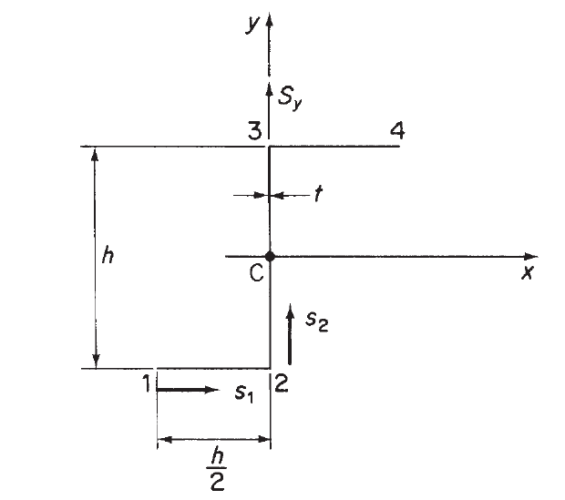

SECTION B

Answer any four of the following question: (Each carrying 10 Marks)

2. A thin-walled closed section beam has the singly symmetrical cross-section shown in Fig. Each wall of the section is flat and has the same thickness t and shear modulus G. Calculate the distance of the shear centre from point 4. (10 Marks)

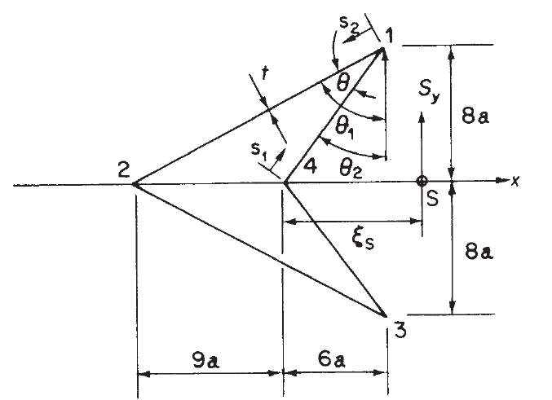

3. a) Evaluate the surface failure due to fatigue and its causes. (5 Marks)

b) Discuss conventional non-destructive testing methods. (5 Marks)

4. Analyze the production methods of nano-sensors. (10Marks)

5. Illustrate the significance of sensors in the aerospace industry. (10Marks)

6. a) Analyze numerical techniques used for the solution of PDEs in SHM. (5 Marks)
b) Differentiate between Diagnosis and prognosis. (5 Marks)

7. a) Illustrate the procedure for simulating the damage to the Aircraft. (5 Marks)
b) Describe the working of onboard SHM with two examples for aircraft. (5 Marks)

********

